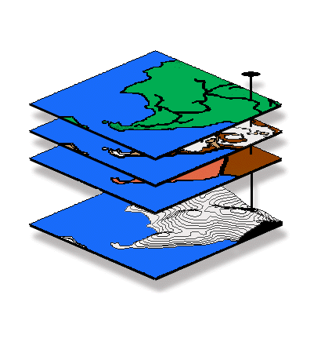

GIS "Tool-Time" Brown-Bag Session, DU Geography

Analyzing Spatial Data:

Spatial Relationships and Modeling

Presentation by Joseph K. Berry, Keck Visiting Scholar

…a two-hour session with “hands-on” exercises in map analysis, spatial reasoning and GIS modeling techniques.

Thursday, May 3rd
10am-12noon and 2-4pm (repeated sessions)
Room 125, Boettcher Center West

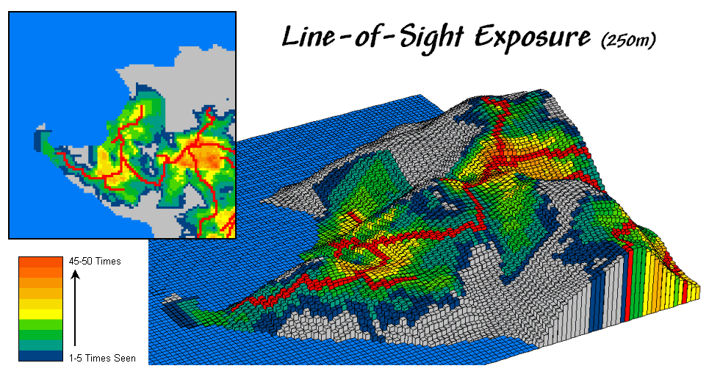
GIS modeling treats maps as organized sets of numbers providing new analysis tools addressing complex issues in entirely new ways. It moves mapping beyond its historical role of graphical inventories and geo-queries of traditional geography, to maps of cognitive abstractions, such as effective proximity, optimal paths, surface flows, visual exposure, slope/aspect, and diversity.

_____________________________________________________________________________________________

The Geography Department is sponsoring a series of “hands-on” workshops for faculty
and students interested in spatial techniques and procedures. Topics include…

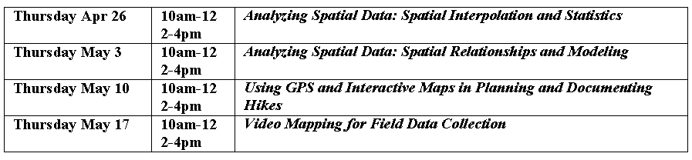
Please direct questions to Joe Berry at DU Extension 7531, email jkberry@du.edu
For more information on the topics, see www.innovativegis.com/basis

